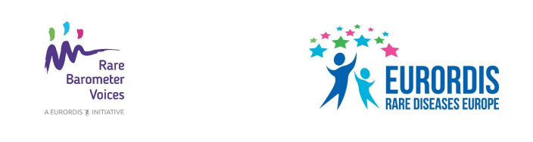
Suggested social media posts

We want to hear from you! Take the new #RareBarometer H-CARE Survey and have your say on the healthcare you receive for your rare disease: tiny.cc/h-care

Are you satisfied with the healthcare you receive for your rare disease? Do you think your healthcare is well organised? Share your views via the new #RareBarometer H-CARE Survey: tiny.cc/h-care

Don’t miss the chance to make your voice heard! Have your say on the healthcare you receive for your rare disease via the new #RareBarometer H-CARE Survey. Survey closes on 29 March: tiny.cc/h-care

