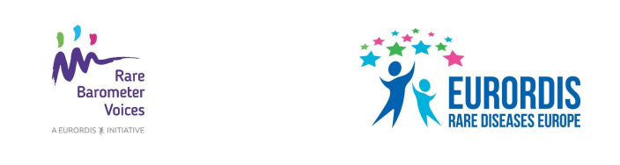
Subject: Have your say on the care you receive for your disease!
You are invited to take the new Rare Barometer H-CARE Survey and have your say on the healthcare you receive for your rare disease.
Please click here to participate in this short survey. It is available in 23 languages and is open to anyone from any country in the world who is living with a rare disease, as well their family members and caregivers. The survey should take no more than ten minutes to complete and closes on 29 March 2020.
This is a not-for-profit initiative set up by four European Reference Networks related to kidney, lung and urogenital diseases and genetic tumour risk syndromes, with the support of EURORDIS Rare Barometer Voices. These virtual networks involve healthcare providers across Europe and ensure that medical expertise travels across borders so that patients don’t have to. EURORDIS-Rare Diseases Europe is a non-governmental patient-driven alliance of over 800 rare disease patient organisations from over 70 countries.
Through asking questions on topics such as whether you receive a choice in your treatment, whether you receive emotional as well as physical care and your experience of follow-up care after a visit to a healthcare professional, we will be able to better measure and understand your satisfaction with the healthcare you receive. Your feedback will help hospitals that are part of a European Reference Network to deliver better healthcare for you or the person you care for. You can find more information on this survey here.
You will be informed about the results of the survey following your participation and the results will also be shared with decision-makers in order to bring about change for the rare disease community.
Please note that your contact details will be kept in secure storage, only accessible to the research team. All of the information shared is completely confidential and anonymised and complies with the General Data Protection Regulation (GDPR).
Thanks in advance for your participation – the more people who respond and share their experiences, the more powerful our voice will be!

